OnBase Instruction Guide – New Hire

Quick Reference Guide – New Hire Request (OnBase)

Who Should Use This Guide
Faculty members, designated proxies, and staff responsible for submitting new hire appointments in OnBase.

System Access Required
You must have the appropriate security roles assigned to access and submit requests in OnBase.

How to Submit
Follow the step-by-step instructions in this guide to complete and submit the New Hire Request form in OnBase.

What Happens Next

You will receive an email confirmation from OnBase once your request is successfully submitted.

The request is routed to the Grants Team for budgetary review and approval.

After budget authorization by the Grants Office, the request is routed to the EBS HR Team.

The EBS HR Team will then move forward with processing the appointment in the order it was received.

Step by Step Instructions
- Log onto OnBase Web Version at docs.erp.ufl.edu

- Select the Document Retrieval icon, in the top left corner.
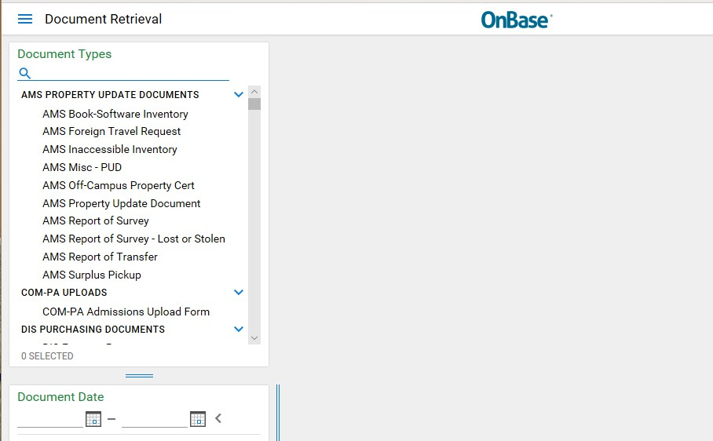

- Next, click New Form.
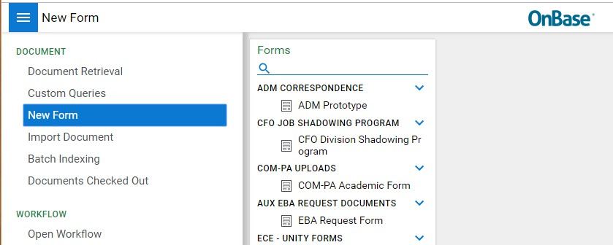

- Then select, ECE – Student Employment, a blank form will appear.
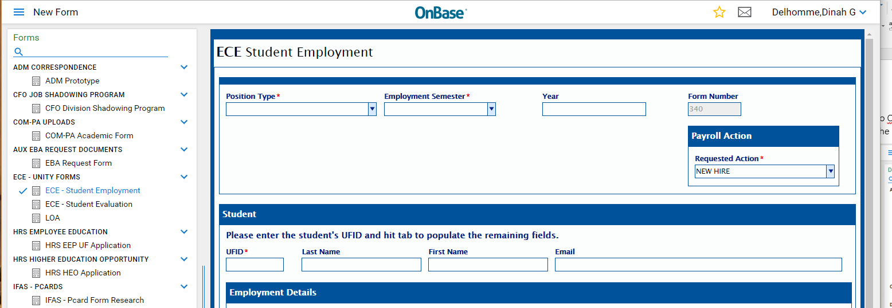

- Complete the applicable fields on the form and click Submit to send your form to the Payroll & Personnel Office for review.

Reminders:
  - The New Hire form is also available under the Life Cycle View in Workflow. Follow the navigation and review images. Open Workflow < Life Cycle View < ECE Faculty LC < Upcoming Employees or Current Employees or Past Employees folders.
  - The Rehire option is only available under the Past Employee folder.

