OnBase Instruction Guide

Reappoint, OPS Semester Break, GA Leave of Absence, Terminate & Rehire

Who Should Use This Guide
This guide is designed to assist faculty members, designated proxies, and staff who submit reappointments, OPS Semester Break requests, GA leaves of absence, Terminate or Rehire actions. To ensure a smooth and consistent process, all these submissions should be completed through OnBase. Following this approach helps keep everything organized and ensures timely review.

System Access Required
You must have the appropriate security roles assigned to access and submit requests in OnBase.

How to Submit
Follow the step-by-step instructions in this guide to complete and submit the appointment request form in OnBase.

What Happens Next

You will receive an email confirmation from OnBase once your request is successfully submitted.

The request is routed to the Grants Team for budgetary review and approval.

After budget authorization by the Grants Office, the request is routed to the EBS HR Team.

The EBS HR Team will then move forward with processing the appointment in the order it was received.

Step by Step Instructions
- Log onto OnBase Web Version at docs.erp.ufl.edu
- Select the Document Retrieval icon, in the top left corner.
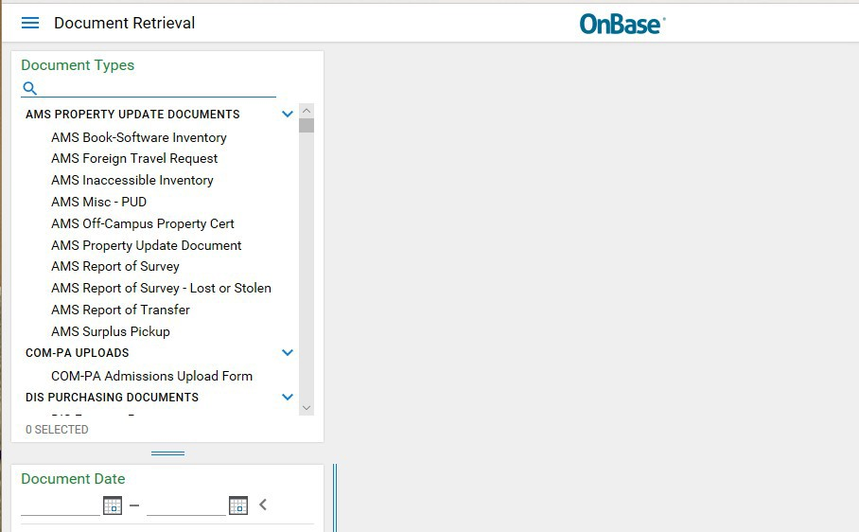
- Next, click Open Workflow – a new window will open.
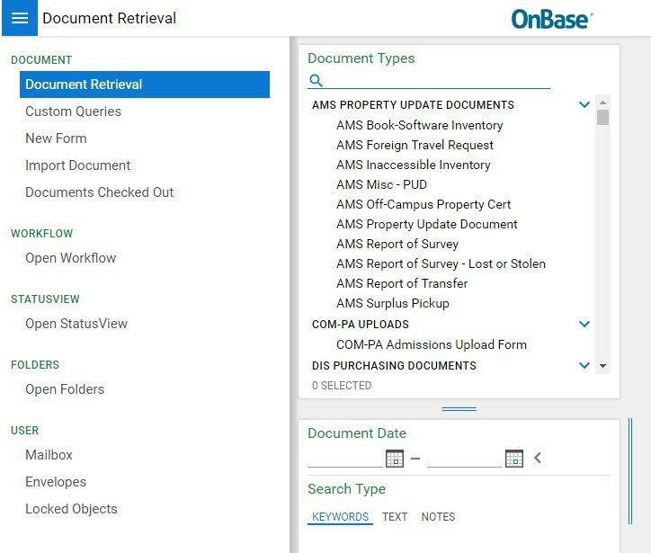
- Under Life Cycle View, click the arrow next to ECE Faculty LC. Then select Current Employees folder.
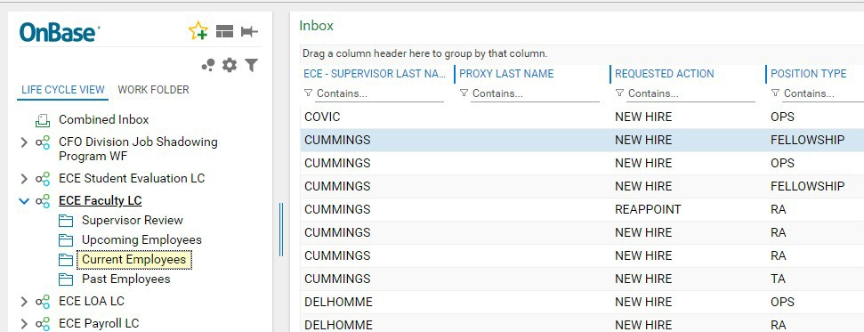

- Filter by, ECE Supervisor Last Name, Proxy Last Name, Student Name etc. to search your student group

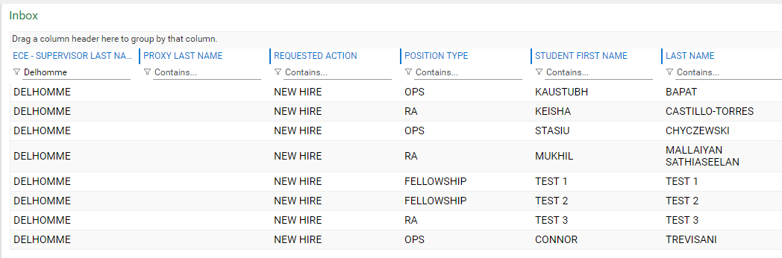
- To REAPPOINT, first (1) select the employee’s name. After selecting employee name, their previous appointment form will appear underneath. Second (2), click the Reappoint button. NOTE: the Department Associate Chair will submit Teaching Assistant and OPS grader appointments (an email will be generated once a form has been submitted).
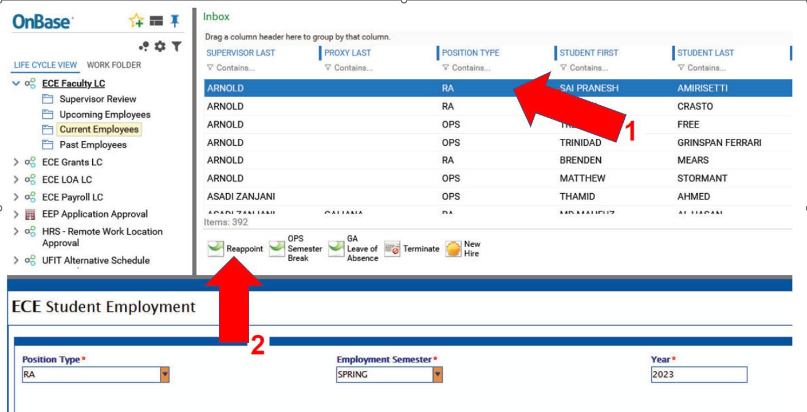

A new form will appear in the Inbox Field. Edit fields in the new form as applicable. (NOTE: DO NOT make any changes to the previous appointment form in the bottom window.) Scroll to the bottom of the top new form (making any updates) and click submit. This will save and send the document to the Payroll & Personnel Office for review.
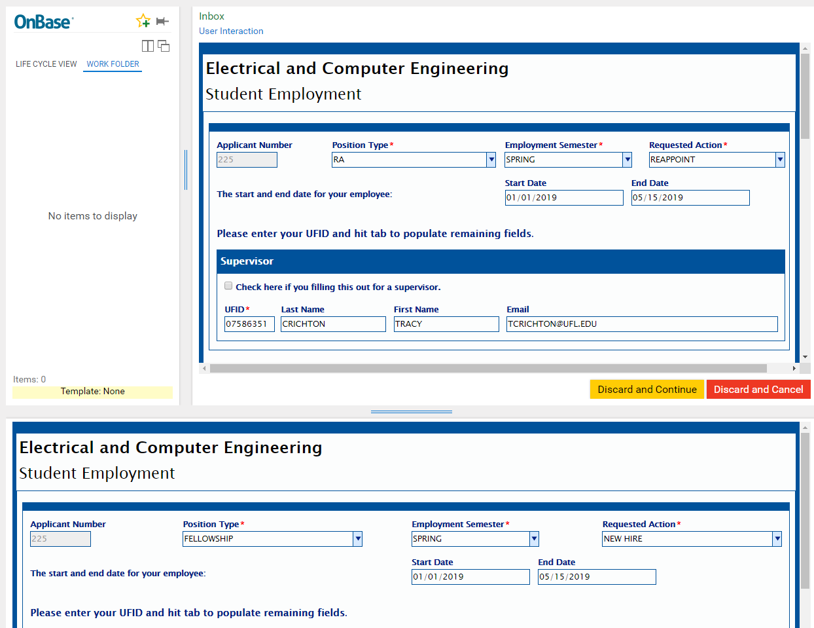
DO NOT MAKE ANY CHANGES TO THIS FORM
- To initiate an OPS SEMESTER BREAK, first (1) select the OPS employee name. Second (2) click the OPS Semester Break button. (Note: if you select an employee who is NOT categorized as an OPS Position Type, you will get an error. Hit OK and make another selection.)
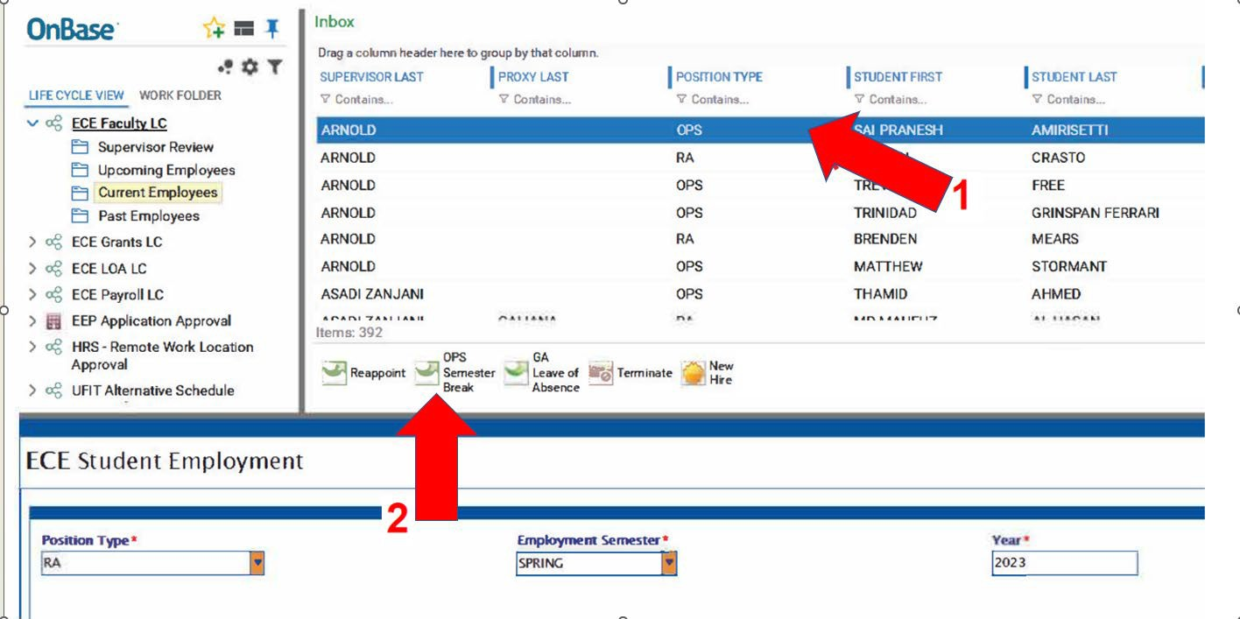

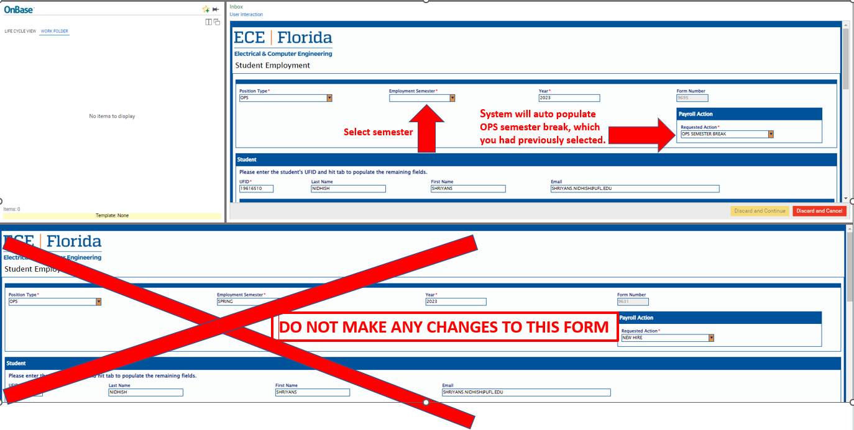
A new form will appear in the Inbox Field. Edit fields in the new form as applicable. (NOTE: DO NOT make any changes to the previous appointment form in the bottom window.) Scroll to the bottom of the top new form (making any updates), enter a thorough explanation of the OPS employee’s semester break (including start and end dates), and click Submit. This will save and send the document to the Payroll & Personnel Office for review.
- To initiate a GA LEAVE OF ABSENCE, first (1) select the GA (RA or TA) employee name. Second (2) click the GA Leave of Absence button. (Note: if you select an employee who is NOT categorized as an RA or TA Position Type, you will get an error. Hit OK and make another selection.)
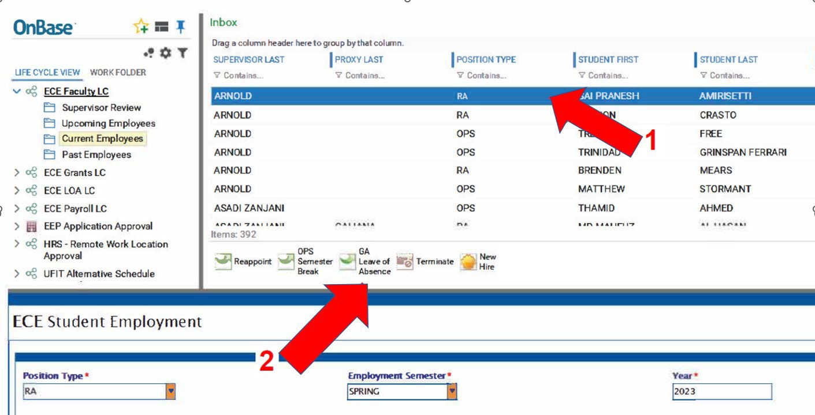

A new form will appear in the Inbox Field. Edit fields in the new form as applicable. (NOTE: DO NOT make any changes to the previous appointment form in the bottom window.) Scroll to the bottom of the top new form (making any updates), enter a thorough explanation of the GA’s employee’s Leave of Absence, and click Submit. This will save and send the document to the Payroll & Personnel Office for review.

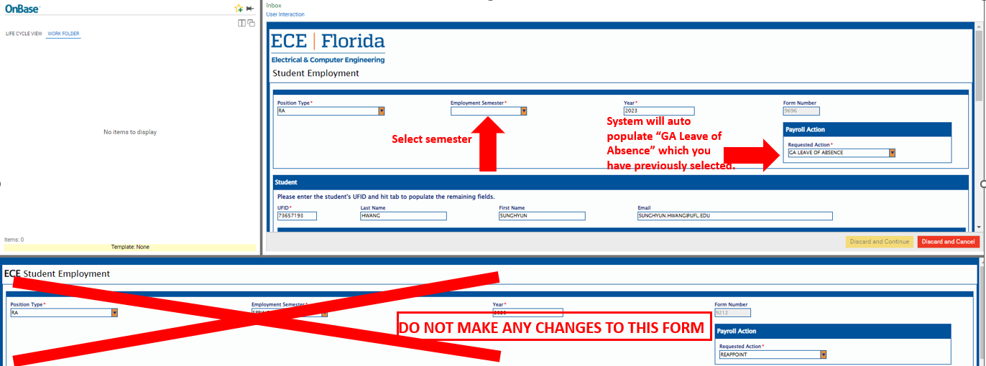
- To TERMINATE, first (1) select the employee’s name. Second (2), click the Terminate button. Enter a reason for the termination (i.e. graduation, internship, poor performance etc...). When reason is entered, click Submit. This will save and send the document to the Payroll & Personnel Office for review.
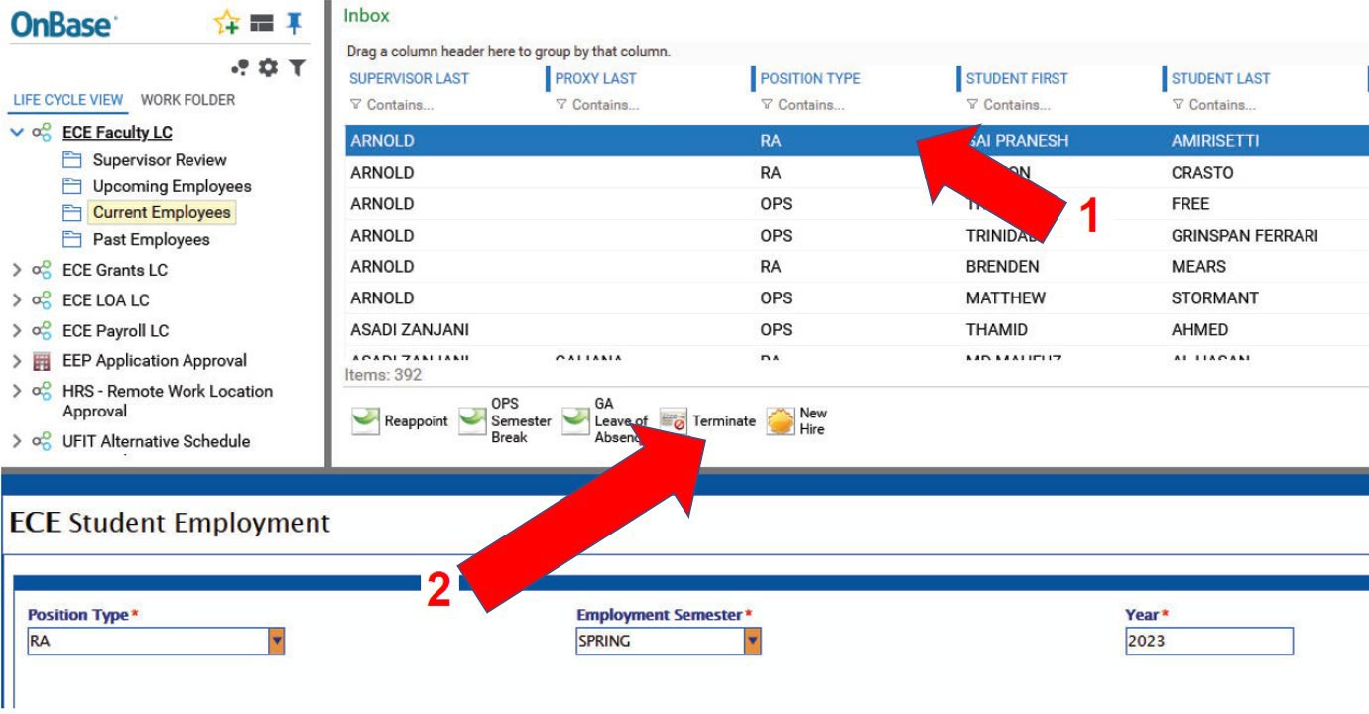
- Repeat steps five through nine to submit all forms under your group to the Payroll & Personnel Office.

- To REHIRE, first select the Past Employees folder under Life Cycle View. Filter by, ECE Supervisor Last Name, Proxy Last Name, Student Name etc. to search your student group. Then select employee name, their previous appointment form will appear below. Click the Rehire button.
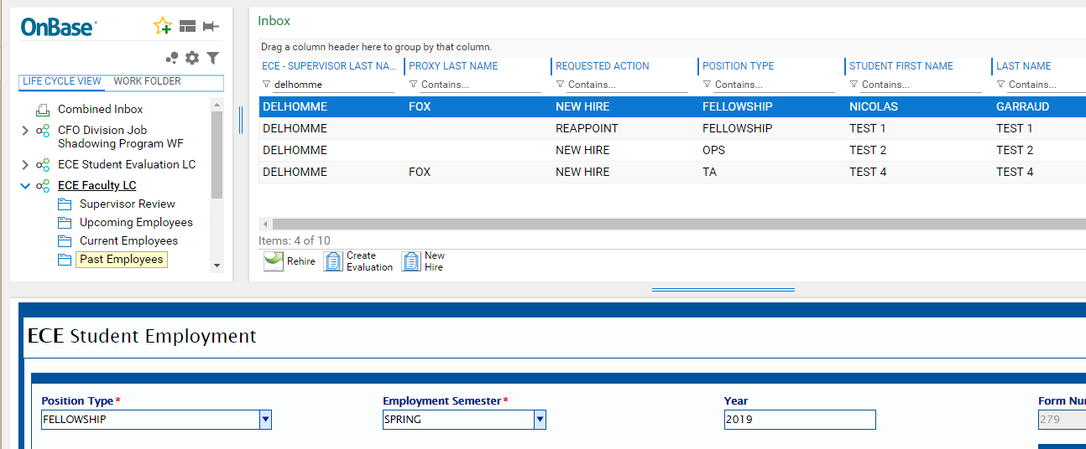
A new form will appear in the Inbox Field. Edit fields in the new form as applicable. (NOTE: DO NOT make any changes to the previous appointment form.) Scroll to the bottom of the new form and click Submit. This will save and send the document to the Payroll & Personnel Office for review.
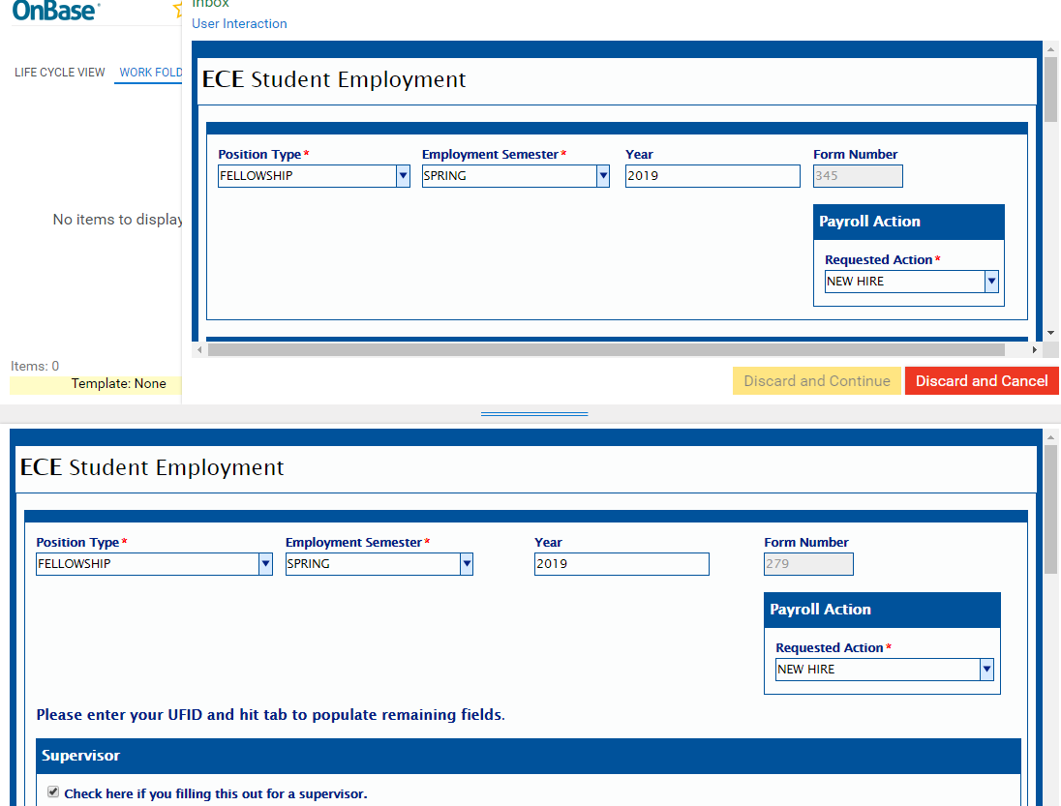
DO NOT MAKE ANY CHANGES TO THIS FORM

Reminders:
  - You will only be able to submit a reappoint or terminate form once (an email will be generated once a form has been submitted).
  - The Department Associate Chair will submit Graduate Teaching Assistant and Undergraduate OPS grader appointments (an email will be generated once a form has been submitted).
  - When reappointing students, you only have the option to Submit or Cancel/Discard. The Discard/Continue button has been deactivated.
  - You should only reappoint or terminate students assigned to you – excluding TA’s and OPS graders.
  - Review your forms and respond promptly.

