OnBase Instruction Guide – Supervisor Review

Who Should Use This Guide
Faculty members, designated proxies, and staff responsible for appointment processing are required to review and resubmit any appointments that have been denied and returned in OnBase from the Supervisor’s queue.

System Access Required
You must have the appropriate security roles assigned to access and submit requests in OnBase.

How to Submit
Follow the step-by-step instructions in this guide to complete and resubmit the appointment Request form in OnBase.

What Happens Next

You will receive an email confirmation from OnBase once your request is successfully submitted.

The request is routed to the Grants Team for budgetary review and approval.

After budget authorization by the Grants Office, the request is routed to the EBS HR Team.

The EBS HR Team will then move forward with processing the appointment in the order it was received.

Step by Step Instructions
- Log onto OnBase web version at docs.erp.ufl.edu using your Gatorlink credentials.

- Select the Document Retrieval icon, in the top left corner.
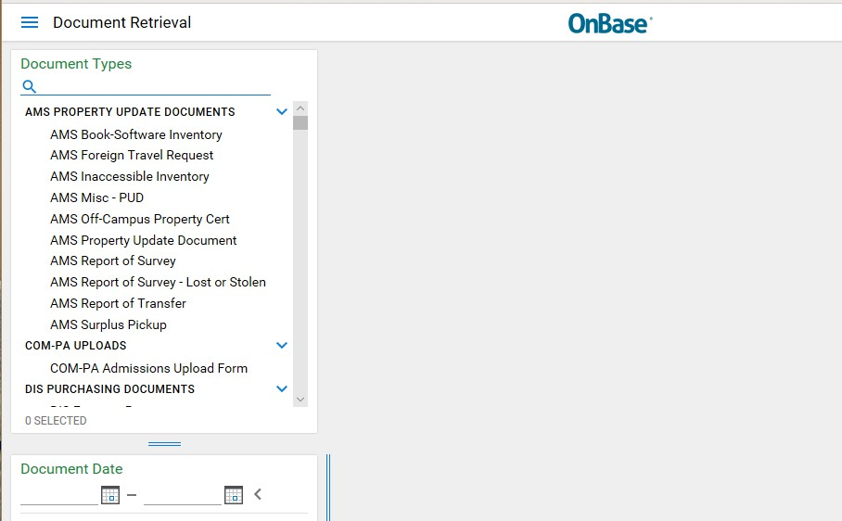

- Click Open Workflow – a new window will open.
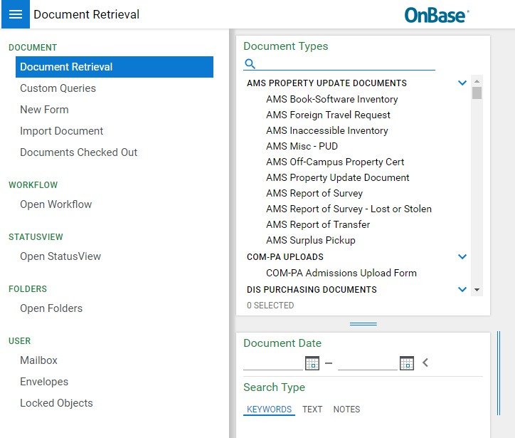
- In Life Cycle View, click the arrow next to ECE Faculty LC. Then select Supervisor Review folder.

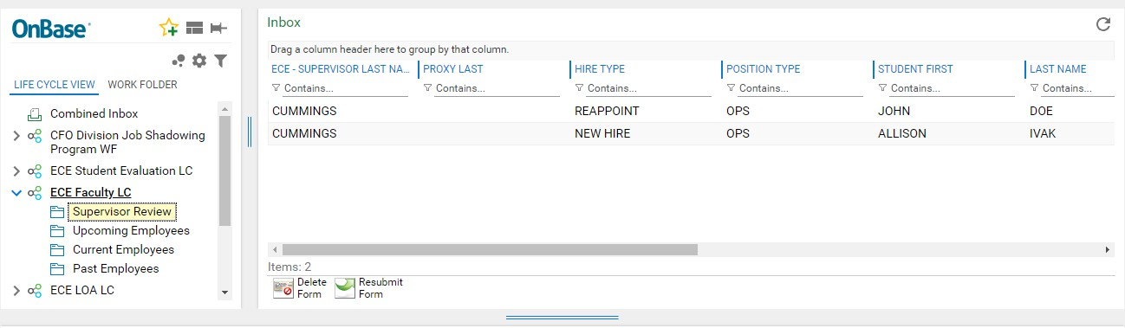

- Search by: ECE Supervisor Last Name, Proxy Last Name, Student Name etc. to find the appropriate form.

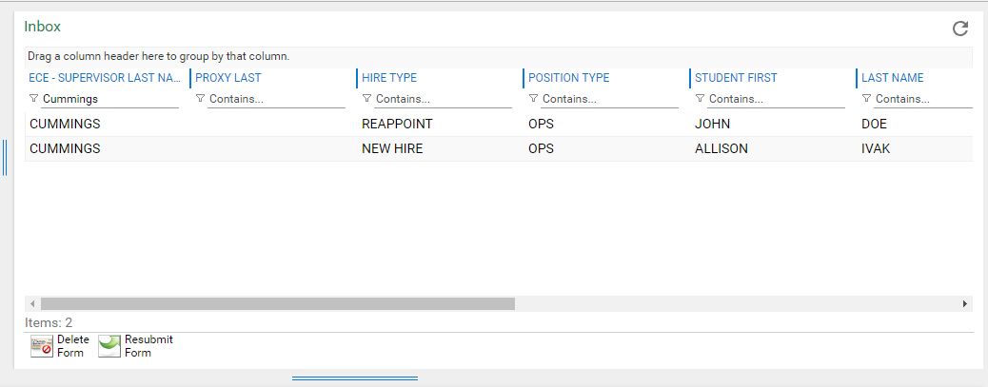

- Select the employee’s name and edit fields in the form as applicable underneath. Then click Submit at the end of the form to save your changes.

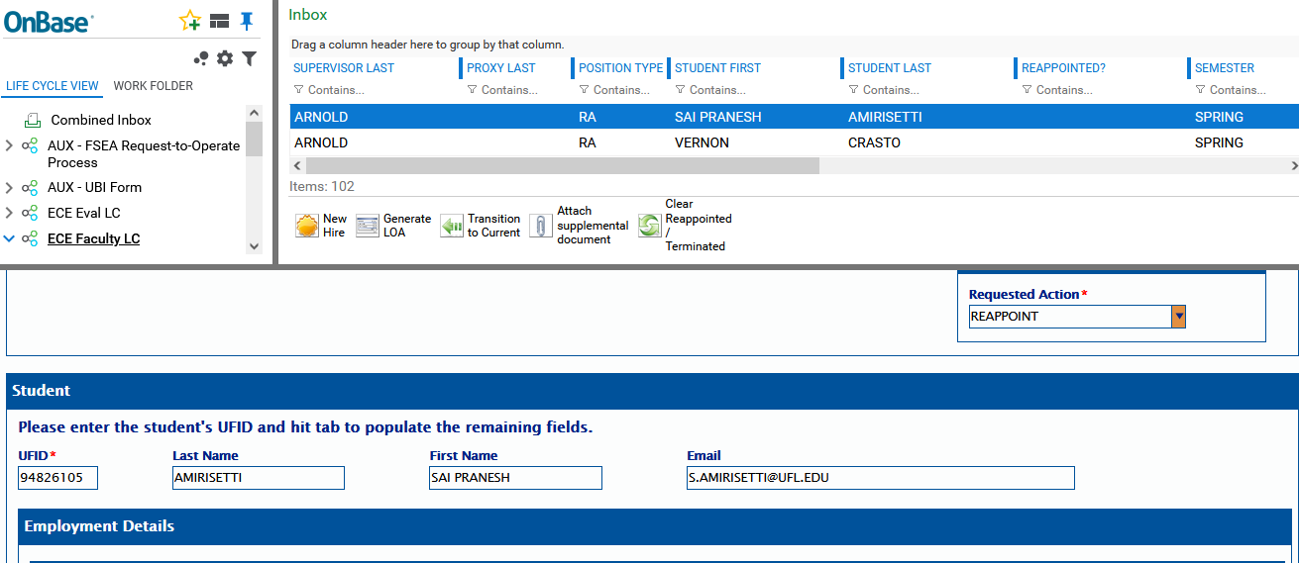
1

2

- Resubmit for Approvals, select the employee’s name then click the Resubmit for Approval button. The form will exit the supervisor review folder, and a confirmation email will be generated.

- Cancel Request, select the employee’s name then click Cancel Request button. The form will exit the supervisor review folder, and a confirmation email will be generated.
- NOTE: Forms cancelled in the supervisor review folder will enable forms in the Current Employee folder to be reassigned (i.e. reappoint or terminate).

Reminders:
  - The Supervisor Review module is for appointment forms that were denied by either Payroll & Personnel or Contracts & Grants Offices.
  - As a supervisor, you have the option to either resubmit the form for approval or cancel the request completely.
  - The Department Associate Chair will resubmit or cancel forms related to TA’s and UPI graders.
  - You should only edit, resubmit, or cancel forms assigned to you – excluding TA’s and UPI graders.
  - Review your forms and respond promptly.

